Number, Patterns and Sequences-Questions
Key Stage 3: 2003 Paper 1 Level 3-5
1.
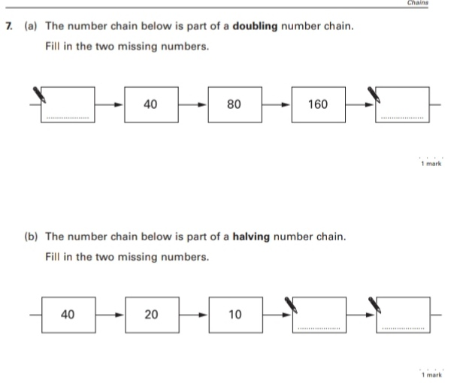
Key Stage 3: 2003 Paper 1 Level 4-6
2.
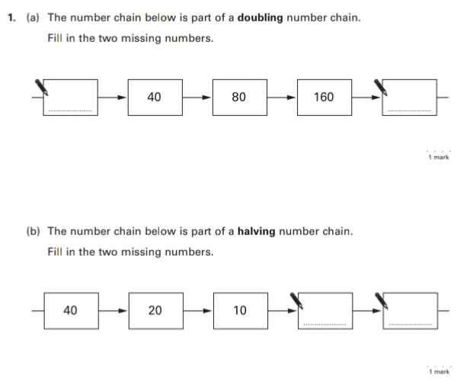
Key Stage 3: 2005 Paper 2 Level 3-5
3.
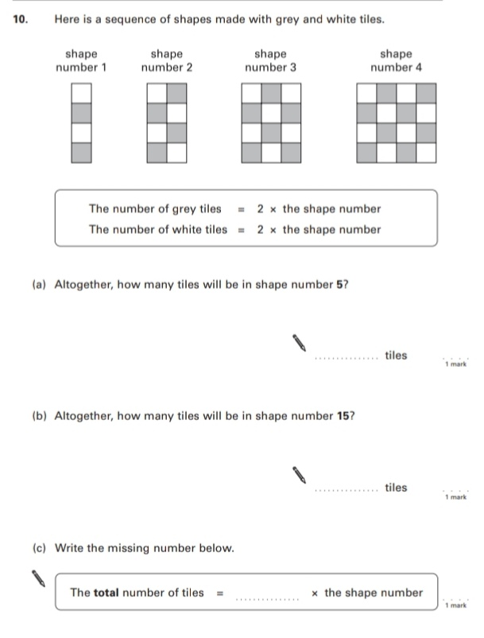
Key Stage 3: 2005 Paper 2 Level 4-6
4.
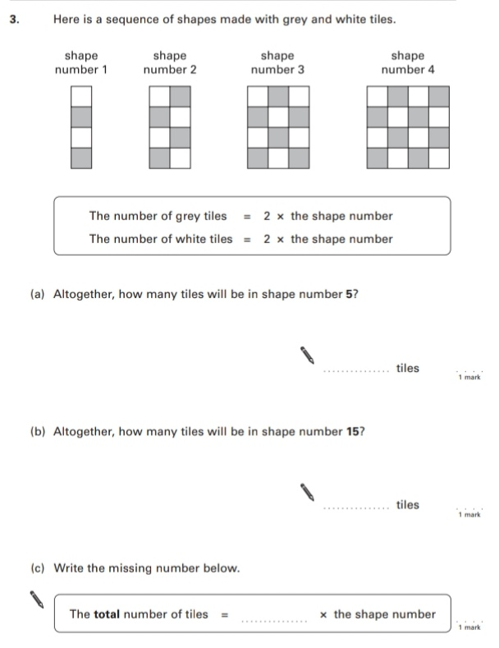
Key Stage 3: 2006 Paper 1 Level 3-5
5.
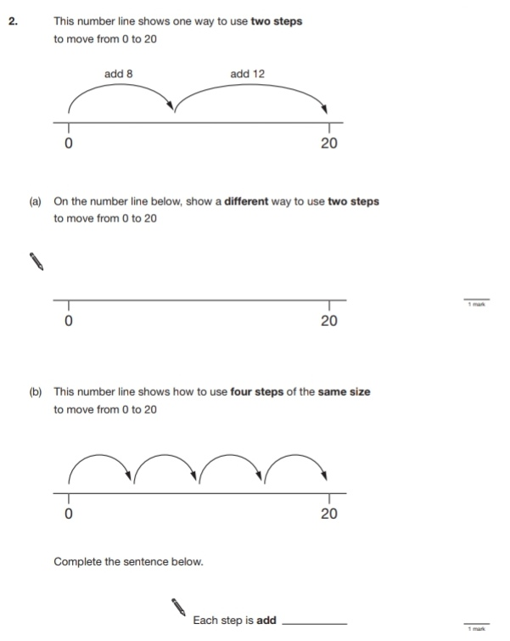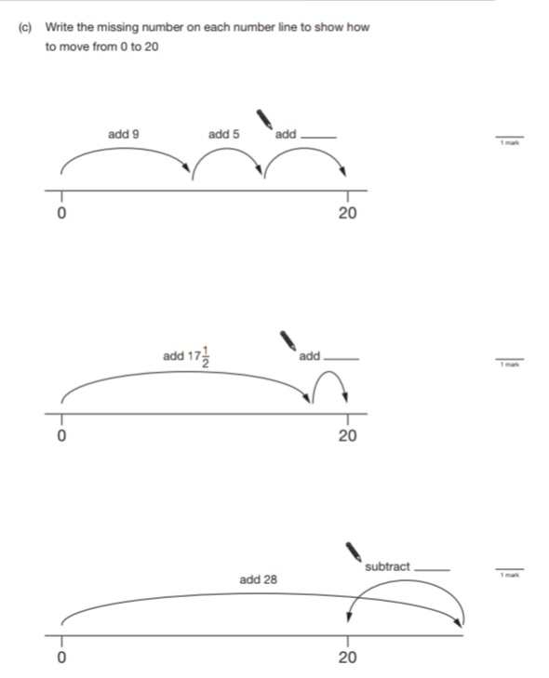
6.
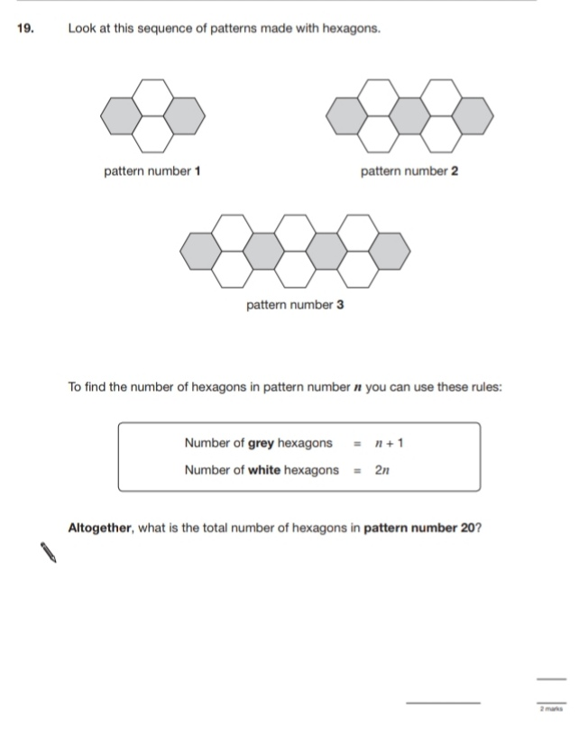
Key Stage 3: 2006 Paper 2 Level 3-5
7.
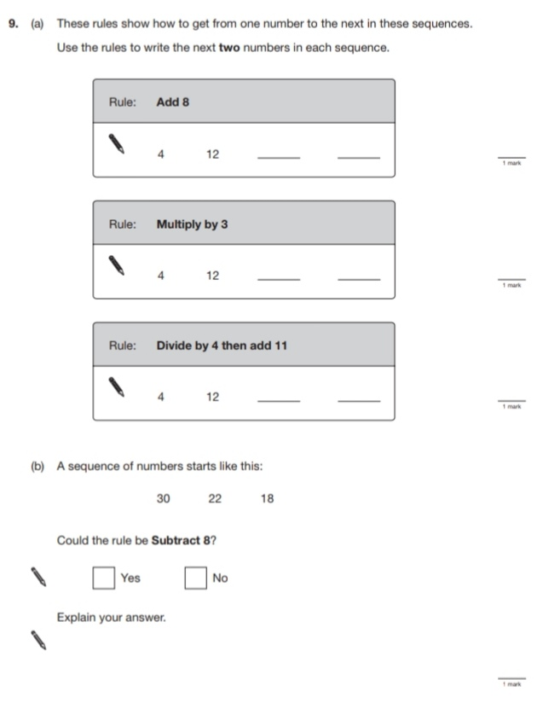
Key Stage 3: 2006 Paper 1 Level 4-6
8.
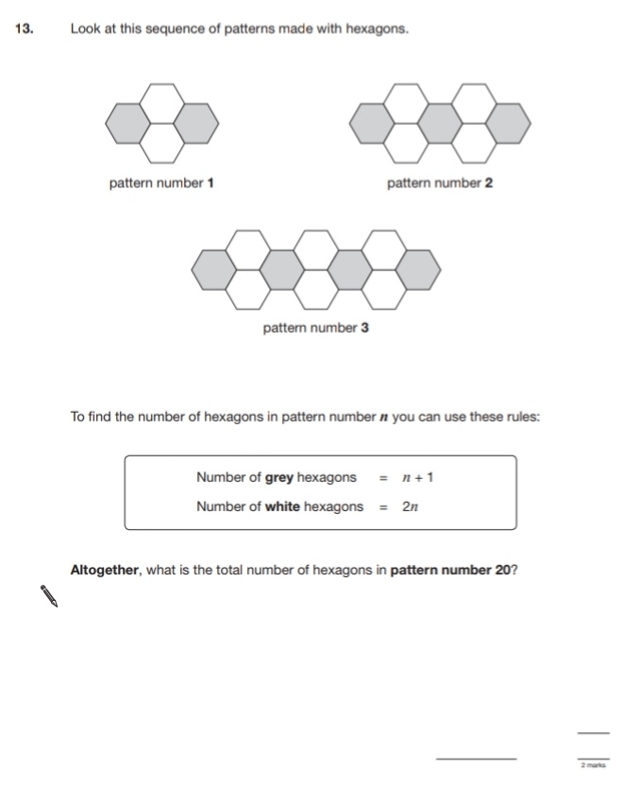

Key Stage 3: 2006 Paper 2 Level 4-6
9.
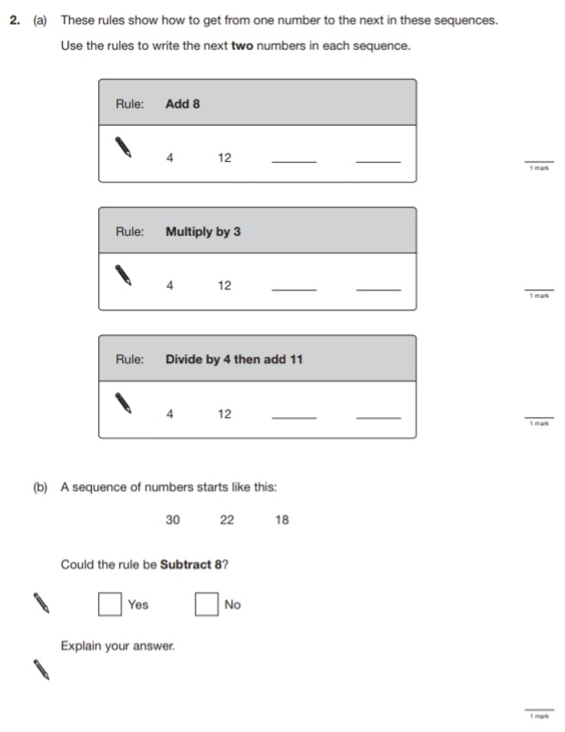
10.
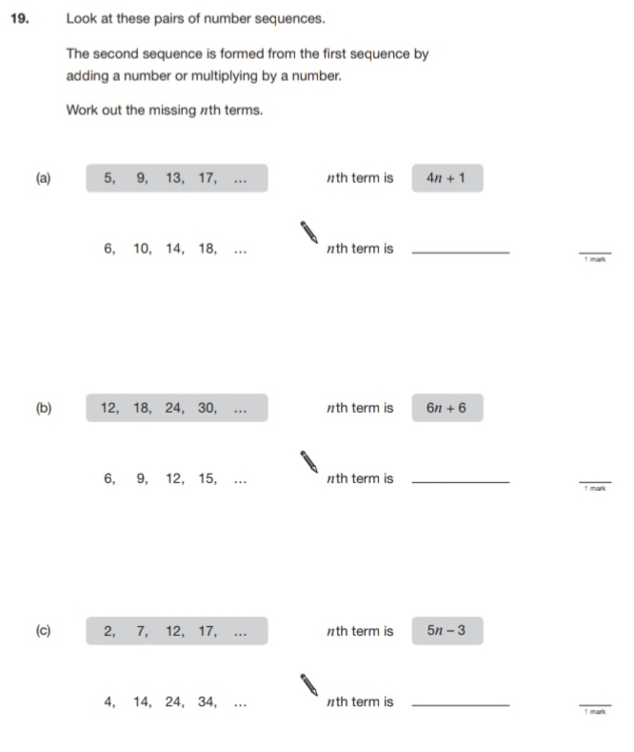
Key Stage 3: 2007 Paper 1 Level 3-5
11.
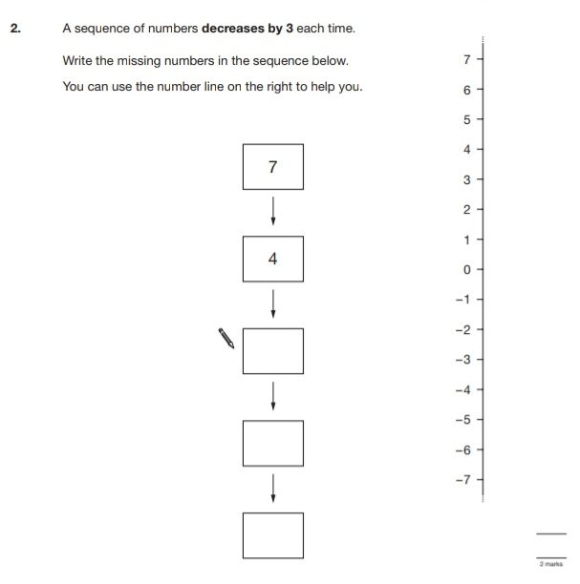
Key Stage 3: 2007 Paper 2 Level 3-5
12.
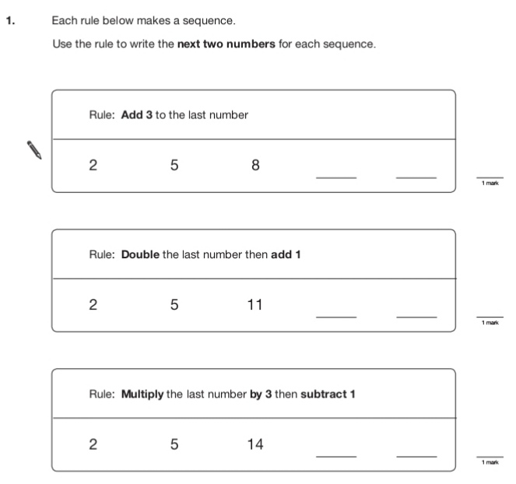
Key Stage 3: 2008 Paper 2 Level 4-6
13.
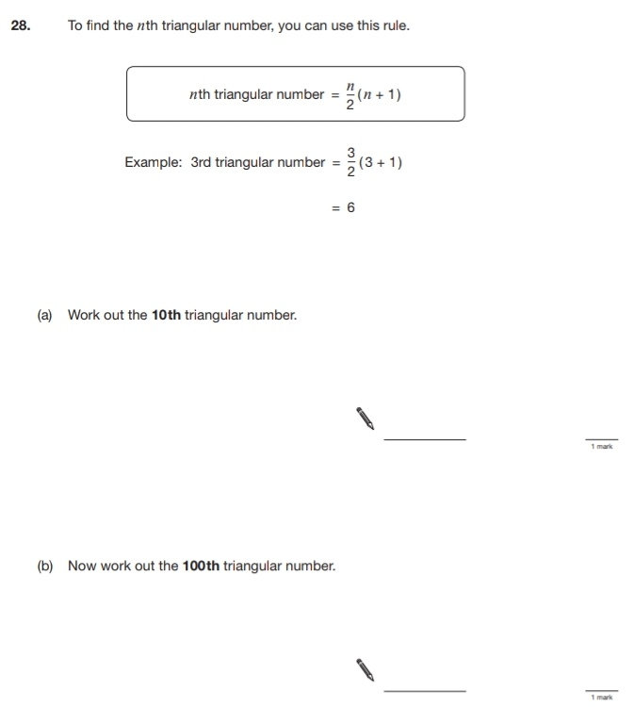
Key Stage 3: 2009 Paper 1 Level 3-5
14.
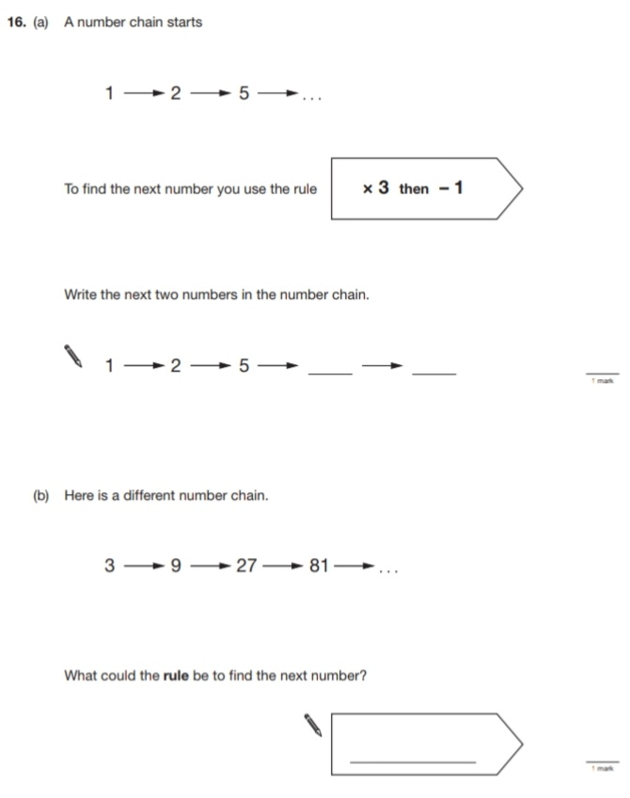
Key Stage 3: 2009 Paper 2 Level 3-5
15.
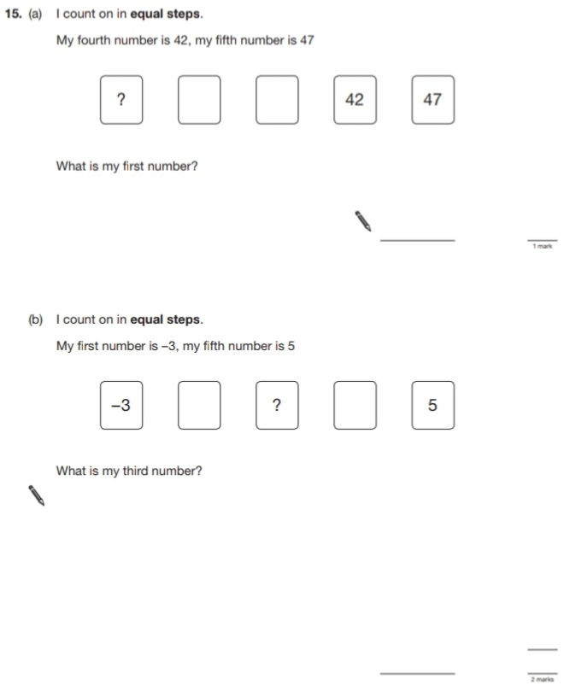
Key Stage 3: 2009 Paper 1 Level 4-6
16.
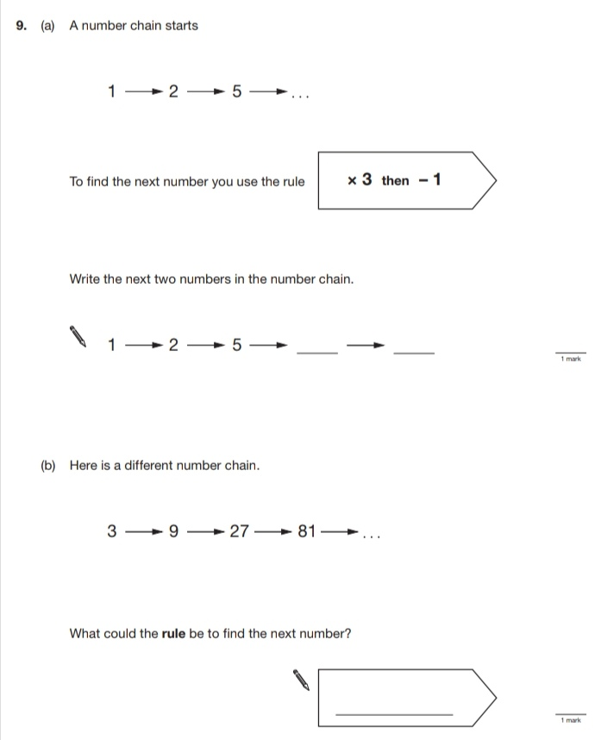
Key Stage 3: 2009 Paper 2 Level 4-6
17.
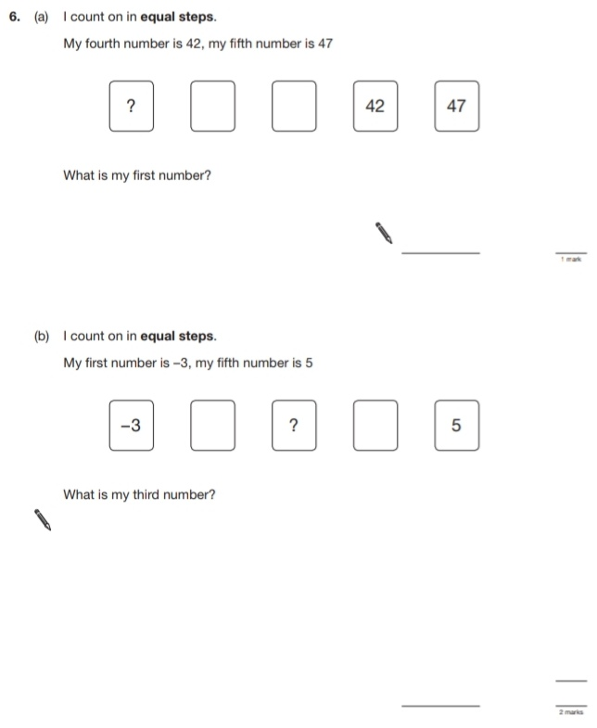
Key Stage 3: 2010 Paper 2 Level 3-5
18.
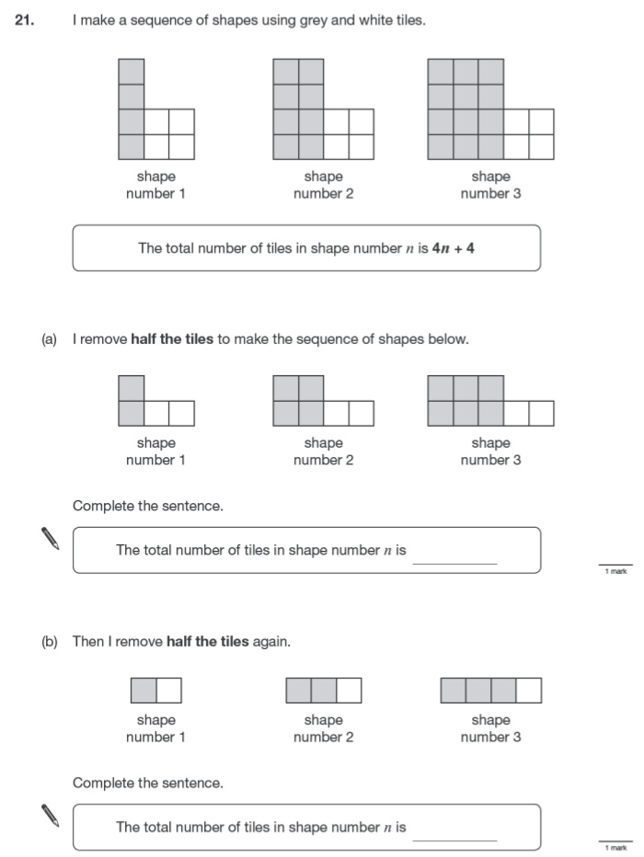
Key Stage 3: 2010 Paper 1 Level 4-6
19.
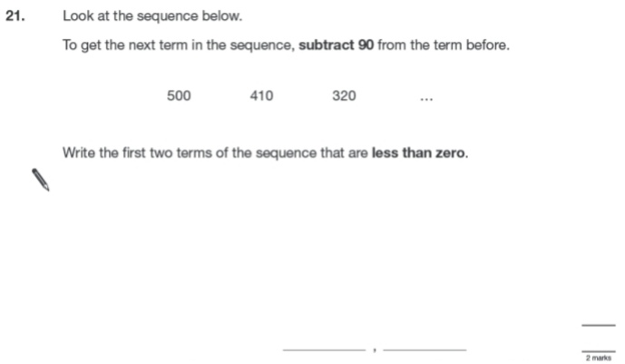
Key Stage 3: 2010 Paper 2 Level 4-6
20.
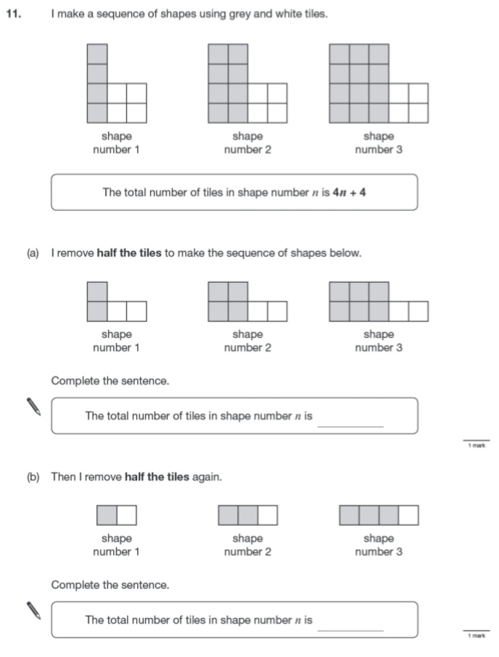
Key Stage 3: 2011 Paper 1 Level 4-6
21.
